

***School of Mechanical & Manufacturing Engineering (SMME),***

***National University of Science and Technology (NUST),***

***Sector H-12, Islamabad***

Program: BE-Aerospace Section: AE-01

Session: Spring 2024 Semester: 2nd

Course Title: Engineering Drawing and graphics (AE-103)

Lab Report

***“*Orthogonal Projection of Objects”**

***Name: Affan Suhail***

***CMS:*** 477560

**Introduction**

**Definition:**

Orthogonal projection is a method used to display three-dimensional objects on a two-dimensional surface in a way that accurately exhibits the relative proportions and angles of the object in each perspective.

**How it works:**

Every 3D object is displayed with three view in an orthogonal projection, which are:

**Front View**: This view shows the object as it appears when viewed from the front. The front perspective is mostly indicated with an arrow pointing towards the object indicating the observing point. It provides information about the object's width and height but cannot show depth.

**Top View:** This view shows the object as it appears when viewed from the top. It provides information about the object's length and width but cannot show height.

**Side View:** This view shows the object as it appears when viewed from the side. It provides information about the object's height and length but cannot show width.

**Objective:**

This Lab report explains the step-by-step procedure of constructing an orthogonal projection of the three given objects. Each object has its own set of steps for construction. There will also be details about the layers and dimension styles used in labelling the dimensions of each Object. All operations performed will be via AutoCAD.

**Object #1**

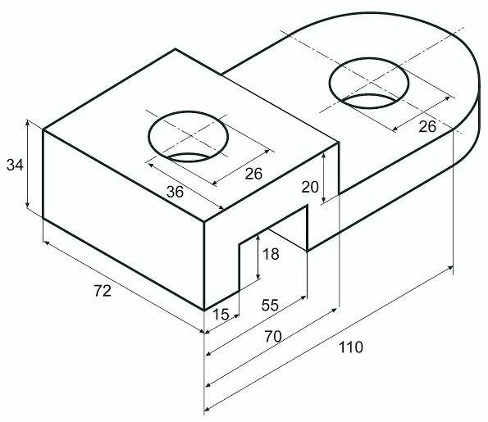

**Procedure:**

**Front view:**

1. We first take the side labelled with the 110-length dimension as our front face.
2. Select line and set starting point at (0,0). Then type the length as 15 along the X-axis.
3. Move the cursor at 90° anticlockwise from X-axis and draw a line of 18 length.
4. Reset the cursor along X-axis and draw a line 40 in length. Then bring the line down 18 in length at 90° clockwise.
5. Now draw a line again along X-axis at length 91.
6. Draw a line of 14 length along positive Y-axis. Then move the cursor back 90° anti-clockwise and draw a line along X-axis (the line will be drawn against X-axis) of length 76.
7. Point the cursor positive Y-axis from that point and draw a line of length 20.
8. Rebound the Cursor back 90° anti-clockwise and draw a line of length 70.
9. The line should now be directly over the starting point with a distance of 34 along Y-axis. Connect the final gap.
10. Make a layer with hidden line applied and a line with Centered line applied.
11. Now find the mind-point of the line of length 70 using the cursor and draw a centered line perpendicularly through.
12. Use offset feature at distance 13 and draw parallel line to the centerline and edit their line property to “hidden”.
13. Repeat 11 and 12 for the line of length 76.

**Top view:**

1. Take a suitable distance below the front view and take an integer starting point.
2. Draw horizontal 70 and vertical 72 from the same point. Now with the length and width make a rectangle.
3. Draw a circle of radius 13 at the center of that rectangle.
4. At a distance of 15, from each side of 72 length, draw a parallel hidden line.
5. Extend the 70-length line to the right by adding 40 in length from both sides.
6. Using the first circle and front view as reference, Draw the second circle of same radius.
7. Using the same center as the second circle draw another circle of radius 36 and trim the left side of it vertically.
8. Use center-marks on the circles with radius 13.

**Side view:**

1. To the right of front view, take a point and draw a rectangle 72 in length along x-axis and 34 in length along Y-axis.
2. From the midpoint of the line of 34 length, draw a hidden line parallel to the line of 72 length that divides the rectangle equally.
3. Now from the midpoint of the line of 72 length draw a centered line parallel to the line of 34 length that divides the rectangle equally.
4. Offset the centered line at a distance of 13 and edit the offset lines into hidden lines.

**Object #2**

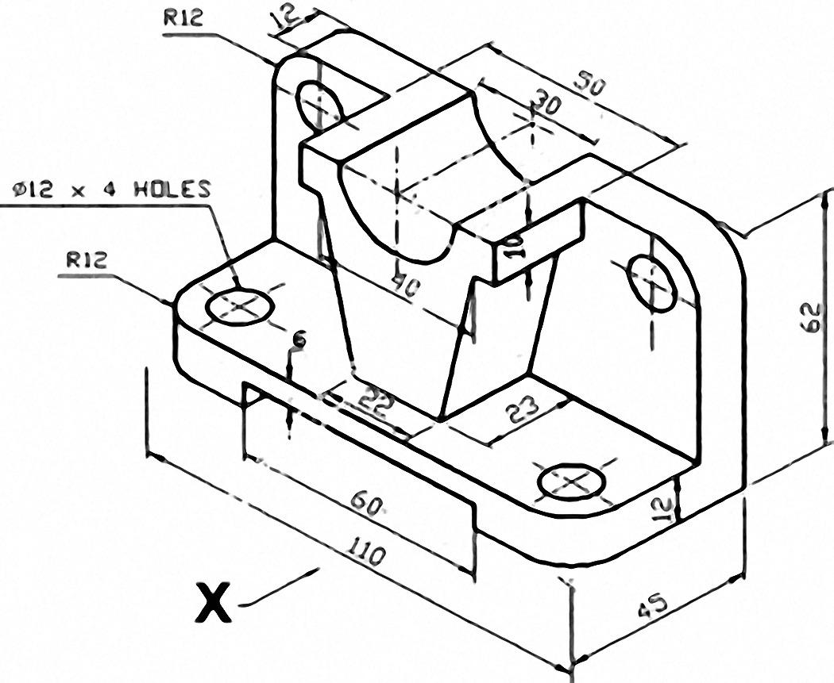

**Procedure:**

**Front view:**

1. At the origin, draw a horizontal line of 110 in length.
2. Draw a line of length 12 vertically down
3. Draw a line of length 25 towards the origin along x axis.
4. Draw a line of length 6 vertically up.
5. Draw a line of length 30 towards the origin along x axis again.
6. Use mirror feature to finish the other half of the base of the object with reference to the midpoint of the base along Y-axis.
7. At the bottom of the base from the right end. Draw a vertical line of length 62.
8. Draw a line of length -40 from x-axis.
9. Draw a line of length -10 from y-axis at -30 point of the line of length -40.
10. Draw a line of length -5 from x-axis from that point.
11. Now connect that point to a point 11 length away from the midpoint of the upper part of the base.
12. Draw a circle from the midpoint of the base such at a height such that the circumference of the circle touches the line of -40 length from x-axis.
13. Trim the upper part of the circle such that only the lower semi-circle remains.
14. Use a fillet of radius 12 to curve join the 62 length and -40 length lines.
15. Draw a circle of radius 6 at the center of the fillet radius.
16. Now draw a center line at 12 length from the side of the base that goes vertically through it.
17. Offset the centerline by a length 6 with hidden lines.
18. Use mirror feature to complete the symmetry.

**Top view:**

1. Draw a horizontal line of length 110 aligned with the front view.
2. From any side draw a vertical line of length 45.
3. Complete the rectangle.
4. Using the front view, draw the semi-circle section from the upper part of the rectangle and centerline it.
5. Draw a line of length 30 below the upper side of the rectangle parallel by 12 in length.
6. Draw a line of length -11 along y axis.
7. Draw a line of length 50 along x axis.
8. Completes the symmetry by repeating step 5 and 6 from the other side of the rectangle.
9. Fillet the bottom sides of the rectangle by radius 12.
10. Draw circles of radius 6 from center point of both fillets and center mark them.
11. Using the front view draw the hidden holes.
12. Draw the hidden cavity of the bottom side of the base using the front view as a reference.

**Side view:**

1. The side view looks like an inverted “L” with additional outlines drawing. It is placed to the left of the front view.
2. Use appropriate dimensions from the figure to draw the side view.
3. Not much needs to be elaborated for this view due to its simplicity and to avoid repitition. Although we need to be careful while drawing the hidden lines since a lot of dimensions are hidden from this view. Hidden lines can be reference from the front and top view.

**Object #3**

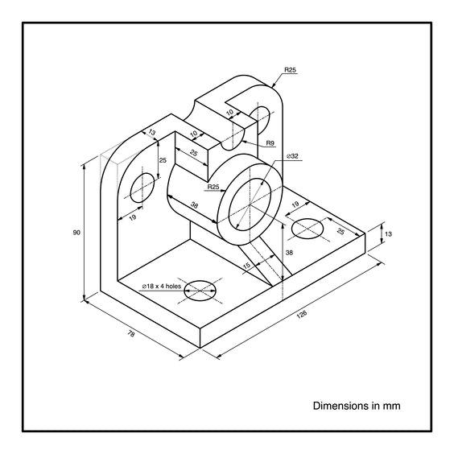

**Procedure:**

**Front view:**

1. Draw a horizontal line 126 in length and vertical line 90 in length from the origin point and make a rectangle.
2. Draw two circles from the midpoint of the 126-length side of the rectangle from the bottom side at an elevation of 38 in length. One circle of radius 16 and the other of radius 25.
3. Draw a line parallel to the 126-length side of the rectangle from the bottom side at an elevation of 13.
4. From that elevated line, draw a vertical line that connects the circle with the line, at 7.5 length distance from the midpoint of that elevated line.
5. Draw a circle of radius 9 such that the center of the circle connects with the upper side of the rectangle. Trim the top side of the circle such that only the bottom half of the circle remains.
6. From both sides of that circle, draw a line of length 10 along x-axis. Then connect those points with the circle of radius 25 (perpendicularly from the initial points).
7. Mark all the circles with a center mark (also the semicircle)
8. Now draw a centerline that is perpendicular to the 126 bottom base line and stretches from the base to the elevated line parallel to it, at a distance of 19 from the 90 length vertical line.
9. Now fillet the top corners of that rectangle with a radius of 25.
10. Draw a circle of radius 9 with the same center as the center of the fillet.
11. Mirror both the fillet centered circle and the hidden hole to the other side of the rectangle symmetrically.

**Top view:**

1. Move down from the front view appropriately and draw a vertical line, of length 78 and a horizontal line of length 126, from a point such that it is aligned with the front view.
2. From a vertical distance of -13 from the top 126 length line, draw another line parallel to it of length 44.
3. Then draw a line of length 25 parallel to the -y-axis from the end point and a line of length 38 heading the same direction starting at a point that is 6 less in length from the 44 length line.
4. Now extend both lines horizontally again to the center of the rectangle.
5. Draw a vertical line of length 38, from the top side of the rectangle from a distance of 54, heading at -y-axis.
6. Using the front view as a reference draw the hidden holes.
7. Using the front view as a reference again, draw a circle at an elevation of 25 from the bottom base.
8. Draw a vertical line that connects the base with the 26 radius circle border perpendicularly at 7.5 length distance from the midpoint of the bottom base line.
9. Now mirror all details of the rectangle such that it becomes vertically symmetrical.

**Side view:**

1. Move to the left of the front view appropriately and draw a vertical line, of length 90 and a horizontal line of length 78, from a point such that it is aligned with the front view.
2. Now manually Extrude it with a thickness of 13 length. It should become an L shape.
3. Now taking reference from the top view and front view, fish all the details and implement them all accordingly into the side view.
4. The only thing that differs independently is the line that joins the 25-radius circle border and the elevated base line. It can be done as the last step as a diagonal line is drawn.

**Dimensions Style:**

* For setting custom dimension styles we have to type DIMSTYLE on the input console and press enter until a popup menu occurs.
* Select modify
* Go to the **“Lines”** Tab and select a color of your choice.
* Next, go to the **“Symbols and Arrows”** tab and set arrow size to 2.
* After that, go to **“Text”** tab and set text height to 3. Also select a text color of your choice
* Now go to the **“Primary Units”** tab and set precision to 0.
* Press ok and close the dimension style manager.